DEPARTMENT OF

# COMPUTER SCIENCE & ENGINEERING

## **“Experiment 2.2”**

1. **Aim:**

Interfacing of Arduino/Raspberry Pi with temperature and humidity sensor with real timeapplication.

1. **Objective:**

* Learn about temperature and humidity sensors.
* Learn about IoT programming.

1. **Components Required:**

You will need the following components –

* Arduino Uno R3 board
* Temperature and Humidity sensor
* Breadboard
* Jumper Wires

1. **Procedure**:

##### **Circuit Diagram for Interfacing DHT11 Sensor with Arduino:**

Now that we have completely understood how a DHT11 Sensor works, we can connect all the required wires to Arduino and write the code to get all the data out from the sensor. The following image shows the circuit diagram for interfacing the DHT11 sensor module with Arduino.

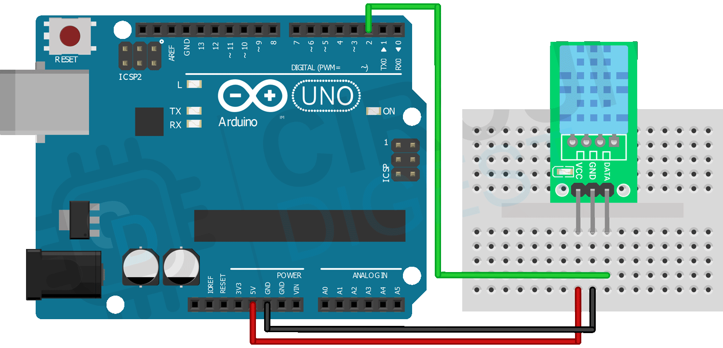

DEPARTMENT OF

# COMPUTER SCIENCE & ENGINEERING

1. **Code:**

#include <Adafruit_Sensor.h>

#include <DHT.h>

#include <DHT_U.h>

#define DHTTYPE    DHT11     // DHT 11

#define DHTPIN 2

DHT_Unified dht(DHTPIN, DHTTYPE);

uint32_t delayMS;

void setup() {

  Serial.begin(9600);

  dht.begin();

  sensor_t sensor;

  delayMS = sensor.min_delay / 1000;

}

void loop()

{

  sensors_event_t event;

  dht.temperature().getEvent(&event);

  Serial.print(F("Temperature: "));

  Serial.print(event.temperature);

  Serial.println(F("°C"));

  dht.humidity().getEvent(&event);

  Serial.print(F("Humidity: "));

  Serial.print(event.relative_humidity);

  Serial.println(F("%"));

  delay(delayMS);

}

1. **Output:**

DEPARTMENT OF

# COMPUTER SCIENCE & ENGINEERING

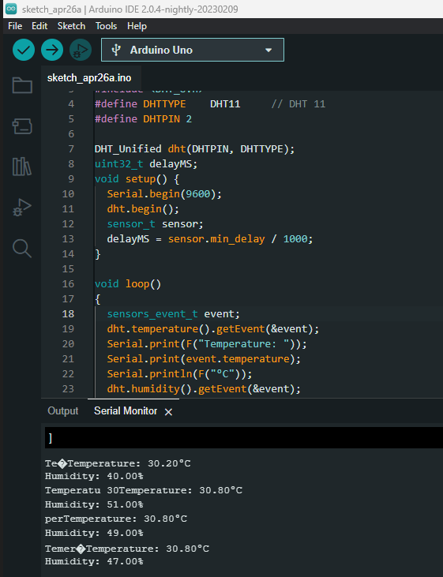

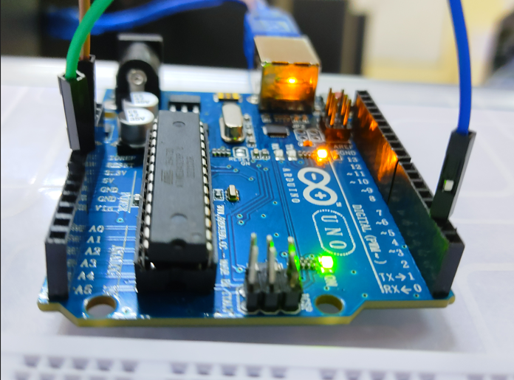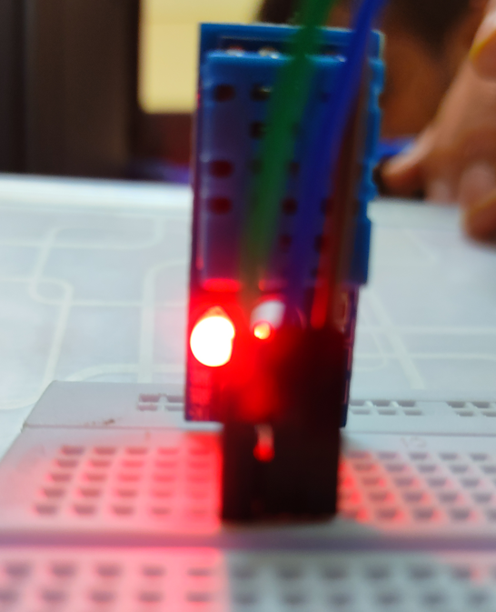

DEPARTMENT OF

# COMPUTER SCIENCE & ENGINEERING

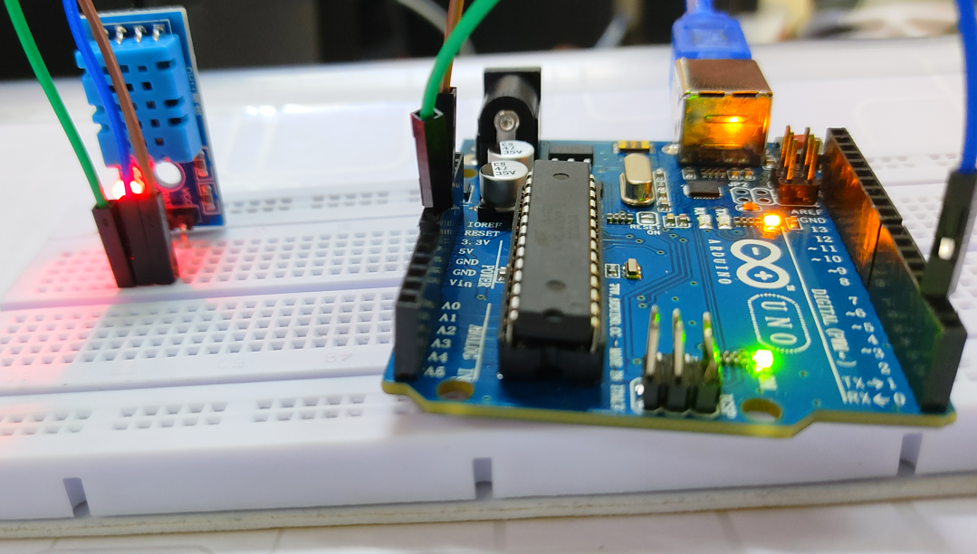

**Learning outcomes (What I have learnt):**

* Learnt about temperature and humidity sensors.
* Learnt about IoT programming.
* Measured the temperature and humidity of environment using temperature and humidity sensors.